OVERRIDING MODULES

The goal now is to add a module which will make it possible to and registrate user, how models can be extend, how use new wizard also make a backup of everything we having seeming before.
Polymorphism, that is a concept that we gonna see a lot, in fact this is the implementation that we going to see constantly. Let’s see an example really fast. e.i:
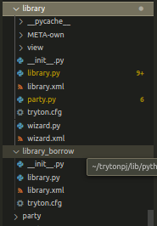

The [library] module and the [library_borrow] are comp-lily different but in the same time are equal what’s means that we can take field of the library and also adding more from the library to library_borrow basically overwriting some functionalities between different s modules.

PoolMeta
As we know tryton follow the concept of modular, Modularization enables opportunities for code sharing and building multiple apps from the same foundation. Modules are effectively building blocks. Apps should be a sum of their features where the features are organized as separate modules.
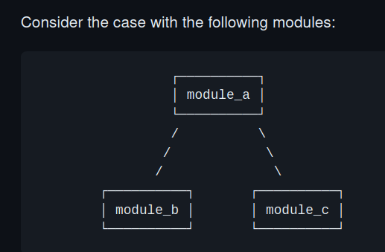

What does means all of this? We can use the module_a without of having the module_b and vice-versa basically it make the app independent of other, what means more organization and order developing. This basically allow us to Inheritance from other modules in ours and overwritten them too.
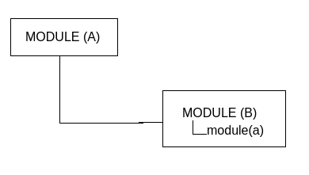

In this case party will be considered the MODULE(a) and library will be considered the MODULE(B) let's dig into this.
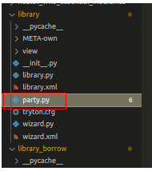

In this case the module added in library for consistency the name must to be the same as the other module that we want inherit from the other folder.
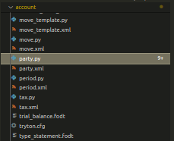

In the module created in (library) called party.py we need to import all of this.
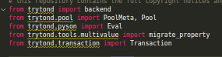

It’s important because we going to need it to extract some functionalities and filed form the original module party.
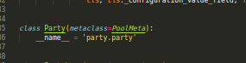

For basically understanding we Create a class called (Party) with the same __name__ that original module this important after all, because the PoolMeta gonna need to passed the original class party.All of this action happen under the hook PoolMeta basically store all the modules taken then form the Database.
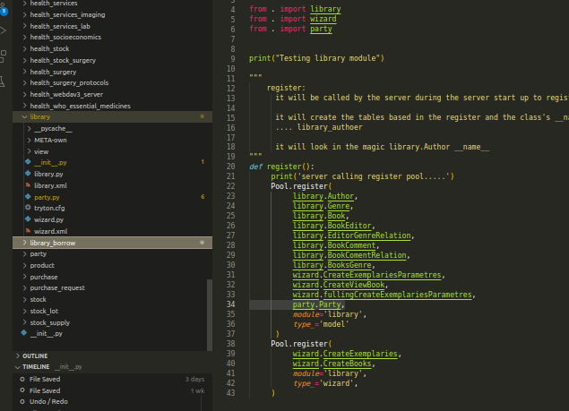
\

Moving to the next step. This must to be register in the __int__.py register so making available in the modules.

